Vadose Zone Data Formatting Tutorial
Submitting Historical or New Data for Inclusion in the Nebraska Vadose Zone Database

By: Jordan Shields, University of Nebraska Water Science Laboratory &
Lacey Bodnar, Daugherty Water for Food Global Institute

This tutorial assists data providers, such as city and Natural Resources District (NRD) managers and staff, with formatting vadose zone nitrate monitoring data to add to the Nebraska Vadose Zone database. The overall goal for this project is to gather, organize, and share vadose zone nitrate data, as well as monitoring data for other chemicals or compounds pertinent to groundwater management, in a single standardized database. This data will be accessible to the public to view and download for historical monitoring and research purposes, and to determine how changing management practices affect subsurface nitrate accumulation and transport. The data will be available in a free, interactive, and online GIS map, shown in Figure 1. All data are treated as confidential and kept on a secure server. Landowner names are not available through the website.

Data providers should use the color-coded, preformatted Excel workbook entitled “Vadose Zone Sample Format” available on the Nebraska Vadose website to submit historical or new data to the University of Nebraska Water Science Laboratory for inclusion in the Vadose Zone database. The sections of this tutorial correspond to individual pages in the “Vadose Zone Sample Format” workbook and provide step-by-step instructions for organizing and formatting data. Workbook fields shaded gray-blue are required; those that are light orange are optional. Please complete the optional columns if the data is available. The minimum information required for a core to be included in the Vadose Zone database are: 1) collection date, 2) a core name, 3) location data, 4) depth of each sample, and 5) nitrate concentrations. Additional guidance on data to be included in the database is available in the “Data Reduction” Standard Operating Procedures (SOP) document on the Nebraska vadose website.

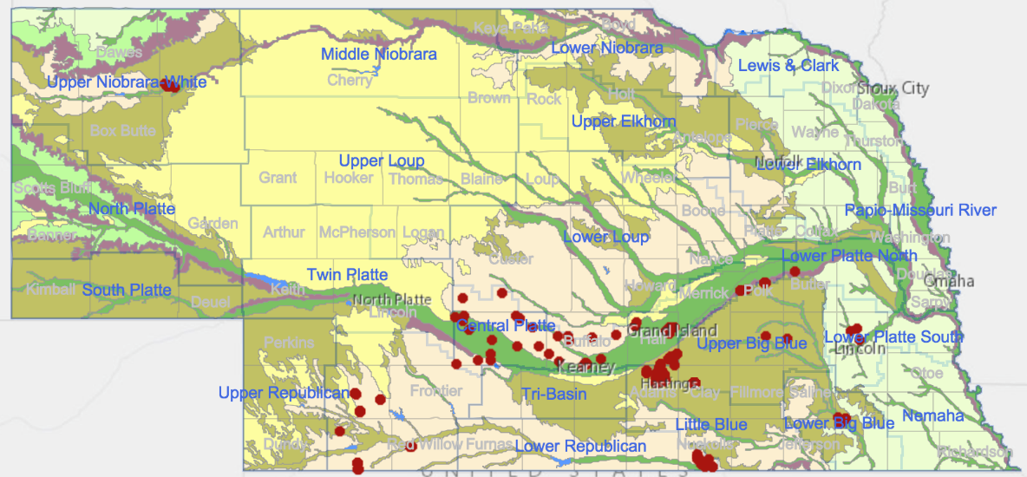

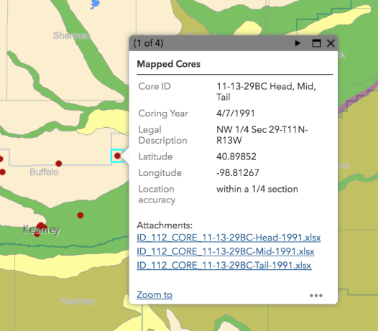
Figure 1: Nebraska Vadose Zone Database and Mapping Tool

Above is a screenshot of the interactive GIS map of vadose zone cores in Nebraska. Locations of core data are depicted as red dots. As users click on one of the dots, they receive more location data and links to download an Excel file containing individual core data (left).

DATA - tblDATASOURCE

The workbook that data providers will use to submit vadose data is “Vadose Zone Sample Format.xls.” The first page of this workbook, shown in Figure 2, requests information on the source of the data. This data table is not for public distribution; it simply allows the database managers to contact the owner of the data in case any questions arise.

Figure 2: Data Source Example Table

Column A: Data Source ID – Start with the number 1. This number corresponds to the first organizational source of the data. If there are multiple sources for data, count up for the next sources.
Column B: Organization Name – Name the organization providing the data. This will likely be the entity employing the person entering the data (e.g. Central Platte NRD, Nebraska Department of Environmental Quality, etc.). If not affiliated with any organization, write N/A.
Column C: Contact Name – Name the specific person within the organization that the database managers can contact if any questions arise.
Column D: Address 1 – Write the mailing address of the organization.
Column E: Address 2 – This is an optional field. If the organization has a second line, likely corresponding to a P.O. Box or suite number, write it here.
Column F: City – Write the city that corresponds to the mailing address in column D.
Column G: State – Write the state that corresponds to the mailing address in column D.
Column H: Zip code – Write the zip code that corresponds to the mailing address in column D.
Column I: Phone – Specify the phone number at which the contact person from column C may be reached. This can be a main or direct line.
Column J: Email – Specify the email that questions can be sent to regarding the data.
Column K: Website – Write the website for the organization in Column B.
Column L: Data Source File Name – Write names of the original data files that correspond to each data source. These files should also be submitted to nebraskavadose@unl.edu along with the completed Vadose Zone Sample Format workbook.
Column M: Date Submitted – Write the date that you emailed/will email the Vadose Zone Sample Format workbook and the original data files to nebraskavadose@unl.edu.
Column N: Additional Data – If you have additional vadose zone monitoring data which does not fit within the current scope of this spreadsheet, enter "Yes" to indicate to other users that such information exists. If not, enter "No." If uncertain, leave blank.
Column O: Data Source Comment – Add any comments that you think are important for database management concerning the data source.

DATA - tblLOCATION

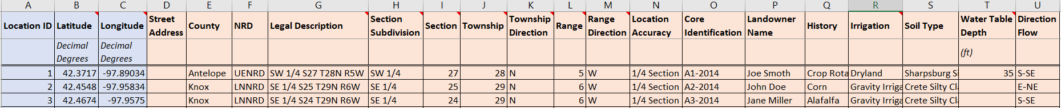
1 2 2

Figure 3: Location Example Table

The second page of the “Vadose Zone Sample Format” workbook, shown in Figure 3 above, covers location data for cores. There may be multiple cores for a given location. The columns of data required for GIS mapping are noted with colored and numbered arrows. The columns shaded in light orange are optional. Either latitude/longitude OR the core location legal description are required in order to add new data to the database. Therefore, if you do not have latitude/longitude available, simply leave these columns empty and complete the legal description. Please complete the additional optional columns if the data is available. See the “Data Reduction” SOP for non-required column descriptions. Some of the columns contain notes, which can be viewed by hovering the courser over the small red triangle in the upper right corner.

The required location information includes:

- Location ID – Start with the number 1. This number corresponds to the first location (latitude/longitude coordinates or Public Land Survey System section) where sampling occurred. It is important to note that there can be multiple cores for each location. Some cores may be in the same location, but at a different time, while others can be in a different quarter section of a single section. If there are multiple cores for a location, multiple core names can be added to column G, separated by commas.
- Latitude and Longitude – These two columns are the latitude and longitude of the core location, in decimal degrees. If coordinate records are in degrees, minutes, seconds, they need to be converted. A good website to do this conversion is latlong.net. Ensure that longitude values are negative (i.e. west longitude).
Street Address – This column is the physical address of the section. As this is not always possible, it should still be the closest address that you can give.
W1/2
NE1/4
Sec 23
Legal Description – The Public Land Survey System (PLSS) is provided in the following format, so that the fractions are written from the smaller (piece of land) to larger (piece of land), moving left to right: (Example) W1/2 NE1/4 Sec23 T29N R5W.

DATA – tblCORE

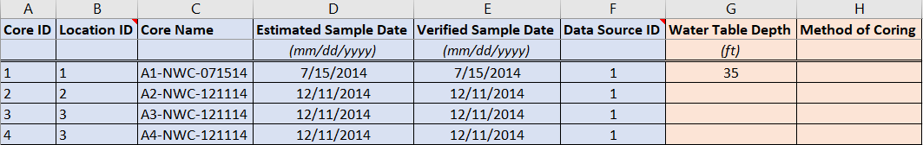

Figure 4: Core Example Table

The third page of the “Vadose Zone Sample Format” workbook, shown in Figure 4 above, covers specific data for each individual core analyzed. The columns of data that are required for mapping are noted with the colored and numbered arrows. If you have any optional data, please include it as well. See “Data Reduction” SOP for additional descriptions.

The required core information includes:
- Core ID – Start with the number 1. This number corresponds to the first core sample at the first location. Each core must have a unique core ID. Even if cores are in the same location but collected at a different time, or if multiple cores are collected within the same section, each core will still receive a unique core ID number. This is necessary to link physical-chemical data, provided in the next page, to the correct core.
- Location ID – This column corresponds to the location ID that was given to each location under the worksheet “DATA – tblLOCATION,” Column A. As described in that worksheet, there can be multiple cores at each location. In the example above, cores 1, 2, and 3 were all sampled in the same section, and so have the same Location ID.
- Core Name – This column corresponds to the name used to identify the core in the Nebraska Vadose database. To avoid duplicate names with other records in the Vadose Zone database, please include an abbreviation of the organization name providing the data (from DATA – tblDATASOURCE,” Column B), as well as the sample date in MMDDYY format, in the core name separated by dashes. In the example above, core A1-2014 was provided by the Nebraska Water Center and was sampled on 07/15/2014. Therefore, the Core Name is written as A1-NWC-071514. Please note that the core name cannot contain spaces. Any spaces should be replaced with a dash (-).
- Estimated and Verified Sample Date – These columns are for the sampling date. If the sampling data is unsure or not included in drilling logs, complete the estimated sampling date and leave the verified sample data blank. Only fill out the verified sampling date if you have direct records of the date that cores were collected. If you have a verified sample date, then enter that same date in both columns.
- Data Source ID – This number corresponds to the source of the data from “DATA – tblDATASOURCE,” Column A.

DATA – tblPHYSICALCHEMICAL

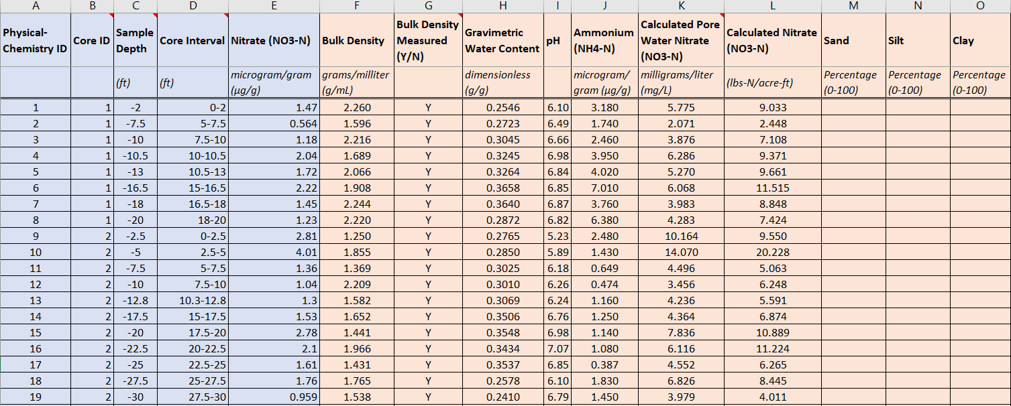

Figure 5: Physical and Chemical Properties Example Table

The fourth page of the “Vadose Zone Sample Format” workbook, shown in Figure 5 above, includes the physical and chemical soil data from the cores analyzed. The columns of data that are required for inclusion in the database are noted with the colored and numbered arrows. Nitrate concentration (μg/g) is required information to add new data to the database. However, additional information on chemicals and compounds relevant to groundwater management is currently being collected and incorporated into the database, including fertilizer, pesticide, and metal occurrence. If you have any optional data listed in this worksheet, please include it as well. See the “Data Reduction” SOP for non-required column descriptions.

The required physical and chemical information includes:

- Physical-Chemical ID – This column is the Physical-Chemistry ID. It corresponds to a depth interval at which physical and chemical analysis occurs. Start with 1 and increase by 1 for each additional entry.
- Core ID – This column corresponds to the Core ID from the worksheet “DATA – tblCORE,” Column A. A single core is usually analyzed at multiple depth intervals. Analysis points from the same core location and date will have the same Core ID. For example, Figure 5 shows 8 physical/chemical analysis points within one core (ID #1).
- Sample Depth – This column corresponds to the bottom of the interval subsampled. With the ground surface as the zero-reference point, these values are all negative. The units are feet.
- Core Interval – This column corresponds to the depth range sampled. The Sample Depth in column C is the second number in the Core Interval range. These values are entered as positive. The units are feet.
- Nitrate [NO3-N] – This column corresponds to the concentration of nitrate in soil on a weight basis of μg/g.

Bulk Density – Because bulk density is used to calculate Nitrate in lbs-N/ac-ft, it is important to specify if bulk density was actually measured in the laboratory analysis, or if the value was assumed. If measured, write “Y” in Column G. If assumed, write “N.”

Calculated Nitrate – Given a concentration of nitrate in μg/g (Column E) and a measured bulk density in g/mL (Column F), calculated nitrate in lbs-N/ac-ft may be determined by the following equation.

$$Nitrate \left(\frac{lbs-N}{ac-ft}\right)=$$
$$Nitrate \left(\frac{μg {NO}_{3}N}{g soil}\right)×Bulk Density (\frac{g soil}{{cm}^{3}})×\frac{1g {NO}_{3}N}{1,000,000 μg {NO}_{3}N}×\frac{1 lbs {NO}_{3}N}{454 g {NO}_{3}N}×\frac{1,233,481,000 {cm}^{3}soil}{1 ac-ft soil}$$

DATA - tblLITHOLOGY

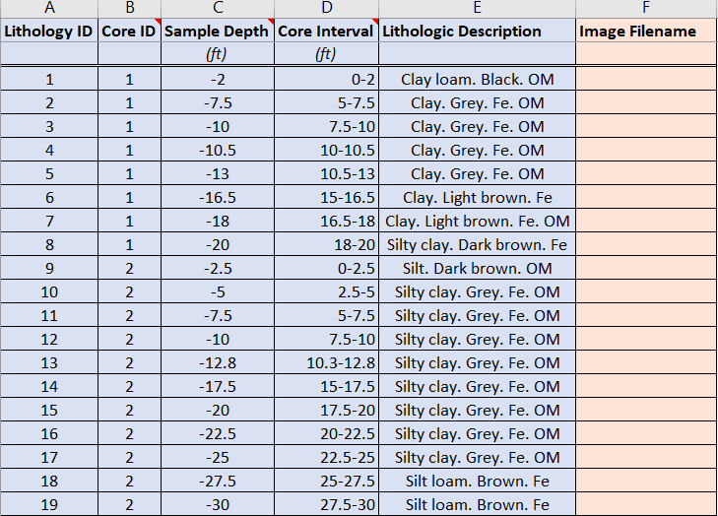

Figure 6: Soil Lithology Example Table

The last page of the “Sample Format” workbook, shown in Figure 6 above, includes the lithological description data from the cores analyzed. The columns of data that are required for inclusion in the database are noted with the colored and numbered arrows. If you have any optional data listed in this worksheet, please include it as well. See the “Data Reduction” SOP for non-required column descriptions.

The required lithology information includes:

- Lithology ID – This column is the lithology ID. Start with 1 and increase by 1 for each additional entry.
- Core ID – This column corresponds to the Core ID from the worksheet “DATA – tblCORE,” Column A. Each interval sampled in the same location and day will have the same Core ID. For example, Figure 6 shows 10 lithology analysis points within one core (ID #1).
- Sample Depth – This column corresponds to the bottom of the interval subsampled. With the ground surface as the zero-reference point, these values are all negative. The units are feet.
- Core Interval – This column corresponds to the depth range sampled. The Sample Depth in column C is the second number in the Core Interval range. These values are entered as positive. The units are feet.
- Lithologic Description – This column corresponds to the lithological description of the analyzed interval. If you are uncertain of the soil lithology classification, a useful soil texture calculator is available through the USDA NRCS.

